Actions for this week:
Preprocess the LARa dataset and train/test models. Think about how to solve the problem of MultiRocket’s slow training speed on the RealWorld dataset, how to improve the later dissertation and literature review to make them more readable, present the KNN, Random Forest, and InceptionTime results on the LARa dataset to my supervisor, and prepare the work for designing the new model.

What did I do this week? Why did I do this?
1. I used only the wearable IMU from the LARa dataset, and only from a single body location (the wrist). I first trained and tested three baseline models: KNN, Random Forest, and InceptionTime.
2. Following my supervisor’s suggestions, I looked for ways to make the subsequent dissertation more readable and more friendly to non-experts.
3. Following my supervisor’s suggestions, I reflected on how to avoid the problematic writing style in the literature review of my previous proposal and on how to write an excellent literature review in the future.
4. I presented to my supervisor the results of KNN, Random Forest, and InceptionTime on the LARa dataset.
5. I continued thinking about how to solve the problem of MultiRocket’s slow training speed on the RealWorld dataset.
6. I prepared the groundwork for designing a new model.
7. I addressed the storage-space problem in my Colab sessions.

Why:
1. Because the time available for the MSc project is limited, and preprocessing multimodal data takes more than ten times as long as preprocessing data from a single IMU.
2. The experiments I write up need to be understandable not only to my university supervisors but also to other professionally trained readers; this is an expected aspect of the academic skills being assessed.
3. Because the dissertation includes a literature review section that counts for 20% of the mark. If I can improve my literature review skills early and send drafts to my supervisor sooner, they can provide feedback faster, and I will have more time to do this part well.
4. To allow my supervisor to evaluate my work and provide suggestions.
5. MultiRocket and MiniRocket together form the fast, lightweight, and accurate baselines of the Rocket family. If either of these baseline models is missing, the quality of my experiments will decrease, so I should avoid removing them unless absolutely necessary.
6. Designing a new model is the most important contribution and innovation in my project.
7. If I exhaust the storage space of a Colab session, all code will stop running, the session will disconnect, and all the previous computation will be wasted.

Outcomes and findings:
1. I successfully completed training and testing of the three baseline models KNN, Random Forest, and InceptionTime on the LARa dataset. At the same time, I kept the code concise, rigorous, and highly reproducible. In addition, the code quality meets the expectations of top computer vision and ubiquitous computing conferences (such as CVPR, UbiComp, NeurIPS) and top journals (such as TPAMI, IMWUT) in terms of experimental rigor, reproducibility, and engineering quality. It is not just a script that “gets the model to run”; it builds an industrial-grade research infrastructure.
2. My supervisor recommended a machine learning book as an example of excellent, accessible technical writing: Hands-On Machine Learning with Scikit-Learn, Keras, and TensorFlow 3e: Concepts, Tools, and Techniques to Build Intelligent Systems. I plan to find time to read it this week.
3. First, I need to follow my supervisor’s suggestion and answer questions such as why human activity recognition is needed, how we recognise human activities, why it is important or interesting, where and how it is used, and how it is detected. Second, I need to regularly look for high-quality literature reviews in the human activity recognition field worldwide and study their strong writing style.
4. My supervisor suggested that I can go deeper and explain the working principles of these models with technical detail, which will add value to my work. Many people only present results or use certain models without explaining how they work. This has been set as a task for next week’s meeting.
5. Although the issue of MultiRocket’s slow training speed on the RealWorld dataset has not yet been resolved, I was fortunate to find that MultiRocket’s training speed on LARa is relatively acceptable.
6. I remembered that in early September I came across a model called rTsfNet, which was published in 2024 and has been evaluated on the RealWorld dataset. I may be able to start from this model and improve it.
7. While training MiniRocket and MultiRocket on the RealWorld dataset, I kept many artifacts to ensure reproducibility, such as the features for every fold of MiniRocket and MultiRocket. These took up too much space and greatly slowed execution. Even though I upgraded to Colab Pro+, giving each session more storage space (190 GB), these artifacts still exhausted the session’s storage quota. My improvement is to prioritise keeping code, configurations, and logs, while compressing some large files for storage. I also started to use more “standardised” data-version management. According to the information I later found, journals and conferences usually do not require huge intermediate features to be committed directly to git; having code, configurations, logs, and re-runnable scripts is enough to fully meet reproducibility standards.

Reflection:
1. At the time, in order to test in advance whether the preprocessing code had any bugs, and whether the later baseline model code was working correctly, I hard-coded the pipeline so that each run only allowed me to manually input one fold, and all models could only be trained on a single fold at a time. Although the code at the end of the pipeline automatically aggregates the results from all previously run folds and produces overall statistics, this setup forces me to wait for each fold to finish, then manually type the next fold index. This is not only cumbersome and disruptive to other work, but also error-prone: if I mistype the fold number, I may need to spend several more hours rerunning the entire pipeline. Finally, if I later design a new model that takes 1 hour per fold, then with an automatic loop over 8 folds I could start the code before going out and see all results when I come back to the flat. But if I have to enter each fold manually, I must type 8 times and stay in the flat for 8 consecutive hours. I need to adjust the code in the future to remove this bottleneck.

2. I carefully read the machine learning book recommended by my supervisor. The writing is indeed very good: it is very friendly to beginners while still maintaining technical depth. I need to imitate its writing style when I work on my dissertation.

3. I looked up several excellent human activity recognition survey papers from around the world, and they are indeed written in the way my supervisor described. However, they are often long and very detailed. In contrast, my dissertation has a strict word limit, so I need to think about how to write well while staying within that limit.
Example:
https://www.mdpi.com/1424-8220/22/12/4596#:~:text=classes%3A%20mechanical%20kinematic%20sensing%2C%20field,outlooks%20on%20the%20future%20sensing
https://arxiv.org/abs/2001.07416

Through this investigation I also realised that, for a top-tier survey, the references do not have to be chosen only from the most “authoritative” or most highly cited papers. What really matters is a systematic and transparent paper-selection procedure, multidimensional quality assessment, and broad but balanced coverage. It is also not necessary to “include everything”, i.e., every pain point or every method from the last 3–5 years. A top survey aims for coverage that is broad but bounded, highly representative, and methodologically transparent: cover the key dimensions, and in each dimension select the most evidence-rich and trend-representative works for systematic analysis. Finally, it needs to organise and explain the most important history, techniques, developments, and pain points in a field, and to emphasise synthesis, evaluation, positioning, and evidence.

4. Going deeper and explaining, with technical detail, how my chosen baseline models actually work will add value to my project. This is something I had not fully appreciated before. In previous coursework, we did sometimes explain model mechanisms, but the explanations rarely went deep; they often felt like explanations “for the sake of explaining”. If I follow my supervisor’s suggestion, then even compared with designing a very strong new model, I can quite easily increase the contribution and originality of my work by providing these deeper technical explanations.

5. It seems that the reason MultiRocket trains slowly on RealWorld but much faster on LARa is related to the size of the datasets I am using. On RealWorld I use data from all 15 subjects, and the compressed archive is 3.46 GB. On LARa, because my preprocessing keeps only the right wrist and applies strict quality assessment, I end up with just 8 subjects and the compressed IMU-only archive is only 627 MB. Next, I will try training MultiRocket on RealWorld using every acceleration method that does not compromise experimental quality, observe the effect, and then decide what to do.

6. The multi-head 3D rotation module in rTsfNet can explicitly address sensor orientation and mounting-angle issues. Moreover, this model has only been trained and tested on four datasets (UCI HAR, PAMAP2, Daphnet, and OPPORTUNITY), and only with fixed subject-based or trial-based hold-out splits, without strict LOSO. Its strengths and weaknesses make it a very suitable candidate for me to reproduce, test, and improve.

7. I do not need to chase reproducibility too aggressively; my supervisor has said this is a stretch goal. The most important thing is first to complete training of all six baseline models on both datasets successfully.

Terminology explanations:

1. What is “Hold-out”?
Unlike cross-validation, hold-out means splitting the dataset once into three fixed parts and keeping this split unchanged throughout the whole experiment:

* Training set: used to train the model parameters (“practising lots of questions”).
* Validation set: used to tune hyperparameters (such as learning rate and number of layers) and decide when to stop training (“mock exam”).
* Test set: used only once, after the model is fully fixed, to evaluate the final performance (“final exam”).

“Fixed” means that every time you run the code, the samples in the training, validation, and test sets are exactly the same. This ensures reproducibility and fairness when comparing results.

2. What is “Subject-based”?
This is the most critical part. It means that the splitting criterion is the person (subject/ID), not the individual samples.

Incorrect splitting (random split / IID): mix all subjects’ data together, then randomly take 80% for training and 20% for testing.
Consequence: if subject A’s data appear in both training and test sets, the model may “memorise” A’s gait, body shape, or other personal features instead of learning the general concept of “walking”. This makes test scores unrealistically high, but the model will fail when used on a new person.
Technical term: this is called data leakage.

Correct splitting (subject-based): split by person. For example:

* Training set: subjects 1, 2, 3, 4, 5
* Validation set: subject 6
* Test set: subject 7

Meaning: this tests the model’s generalisation ability. In testing, the model faces a completely unseen subject, which matches real-world usage (for example, when you buy a smartwatch, the embedded model has obviously never seen your data before shipping).

3. What is “Trial-based”?
During data collection, each subject usually performs multiple recording sessions. For example: User 1 walks once (Trial 1), rests, then walks again (Trial 2). Each continuous recording is called a trial (or run/session).

Trial-based splitting is often used to prevent temporal data leakage:
Scenario: suppose User 1 performs a continuous 10-minute running trial (Trial 1).
Segmentation: we cut this 10-minute signal into many 3-second windows.
Problem: if we randomly shuffle all 3-second windows, the window at 3:00 may be in the training set and the window at 3:03 in the test set. These two windows are extremely similar.

Trial-based strategy: all windows from the same trial must stay in the same split. Either the entire Trial 1 is in the training set, or the entire Trial 1 is in the test set.

Have I finished this week’s action? What percentage? If not, how to improve?
Completion rate: 70%
I still need to think more deeply about how to improve the readability of the dissertation and raise the quality of the literature review in line with my supervisor’s suggestions. I also need to continue thinking about the design of the new model and about how to speed up MultiRocket training on the RealWorld dataset.

Actions for next week:
* Provide an in-depth, technically detailed explanation of how KNN, Random Forest, and InceptionTime work, and show it to my supervisor next week.
* Continue reading the machine learning book recommended by my supervisor.
* Improve the quality of the literature review according to my supervisor’s advice.
* Use MiniRocket, MultiRocket, and TST to complete training and testing on all folds of the LARa dataset, summarise the results, and report them to my supervisor.
* Continue exploring ways to solve the problem of MultiRocket’s slow training speed on the RealWorld dataset.
* Continue thinking about the design of the new model.

Email exchanges with supervisor Halloran:
Last week, my supervisor asked me how I split the data, and whether I was testing on people whose data had already been used for training.

My reply to my supervisor was:
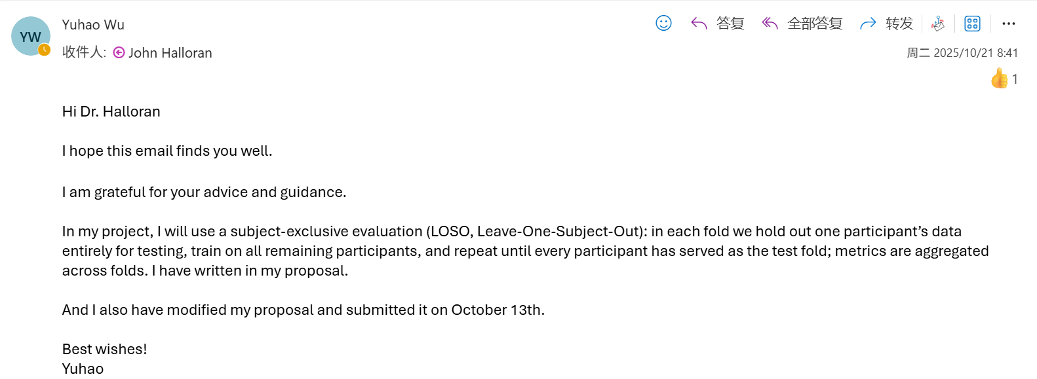

Meeting part:
I showed supervisor Halloran the performance of KNN, Random Forest, and InceptionTime on the LARa dataset.
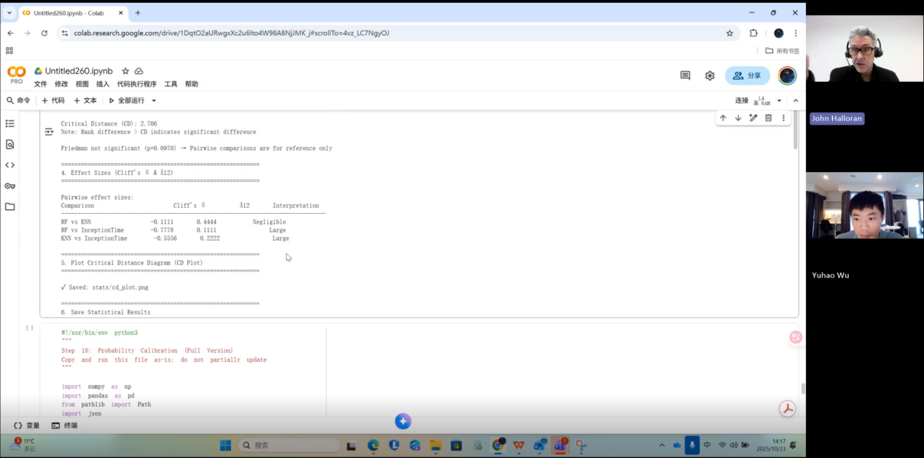
My supervisor’s response and suggestion were:
There is one thing that could significantly improve how you present your results: spend some time explaining how these models actually work. For this kind of work, that is, machine learning, it is now possible for anyone to do it in Colab. For example, people can run models even if they do not understand the internal mechanisms. That is fine; we can use Colab to do these things. But in many cases, users do not really know what they are doing, or why they chose those models. So if you can go deeper and explain, with technical detail, how these models work, you can genuinely add value to your project, and this is exactly what you are good at. Is it okay to arrange it like this? Would one week be too much for you? Is this schedule okay? Would one week be too demanding?

My answer was:
No, it would not. I took a machine learning module last semester, so I already know something about these models. Models like KNN are baseline or classical models. We also often use them as comparisons in many experiments.

My supervisor’s further response and suggestion were:
Good, that is excellent. It is of course very good if you can put what you learned from that module into practice.

Supervisor John Halloran also said to me:
You have made a very strong start and you started very early; you also completed the ethics approval early. That is very good. If you can keep bringing your work to me for feedback and discussion, that would be great.
I like the way you deliver things early; that is very good. If you can keep doing that, it is a very good practice, okay?
As a result, throughout my whole project, I have been consistently following this way of working.

I asked supervisor John Halloran three questions:
The first was: about the requirements for the coursework (the dissertation): do I also need to write the proposal in a way that is friendly and easy to understand for non-experts?

My supervisor’s answer to question 1 was:
Yes, the same principle applies: write for an “informed non-expert” audience. This is a difficult thing to do; the dissertation, the master’s project and so on are not only about learning technical content, but also about learning how to write. I hope to support you, and every student I supervise, in writing good work. One good approach is to learn from how experts write by reading literature reviews. You can look at those papers and see how they handle the writing. Another thing I strongly recommend is finding a really well-written machine learning textbook. It is simply called “Machine Learning”; it is a book that covers the basics but also goes into advanced topics, and it is based on scikit-learn, Keras, and TensorFlow. I will look up this book; it is written extremely well. If you can write in a similar style, that would be very good. It is just an introductory textbook, but the writing is excellent. This is the kind of writing I am talking about. The beginning of the book is written in a very simple way; you can write in a way that is slightly less simple, because the book’s introduction is aimed at complete beginners.
But if you look at how it describes each model later in the book, it is very good, and it matches the level of difficulty of the work you are doing now. It is a very good writing example. What we are talking about now is “intelligible technical writing”, that is, technical writing that is “accessible to a broad audience”—“accessible” here means suitable for a wider group of readers. Does that sound okay? In addition, as I said, when you read academic papers for your literature review, also pay attention to their writing style and how they structure things.


The remaining two questions:
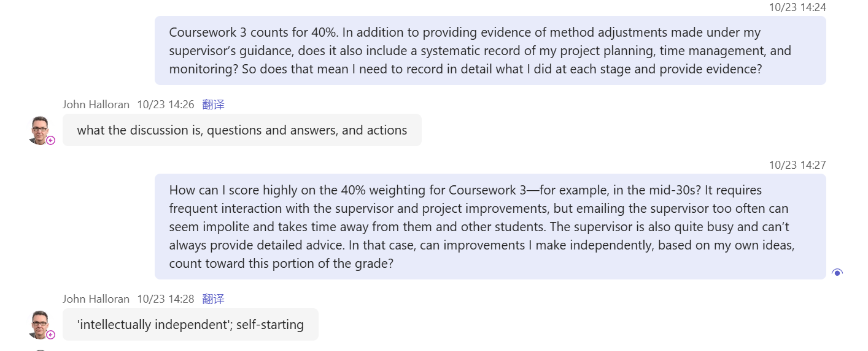
My supervisor’s answer to question 2 was:
What you should do is summarise what we discussed and why we discussed it. That includes: what questions I asked you and how you answered them; what questions you asked me and how I answered them—record these. You do not need to write down every single detail, but there must be evidence that we had these discussions. You also need to explain why we had this discussion, and list the “actions”. For this meeting, the action points include: you need to write out (describe/organise) the three models, and you also need to write up the experiments you have done so far. So the structure can be: discussion content, Q&A, and actions.

My reply was:
Sorry, should I also record some questions like what I did, what experiments I ran, and so on? Do I need to record that kind of information as well?

My supervisor’s answer was:
Yes, that would be very good. You can write about how you set up the software environment, how you obtained all the data—of course you will also write about these things in the dissertation. But as part of the process, you can write what you did in each specific week. You need to include dates, okay? Each week, what activities did you do? That way we know when things happened and why they were done at that time. For example: I did this at this time because it matched the plan I had made. This is the kind of “process” we want to see: that you have a process. And you clearly already do, so I am not worried. This is actually a question many students ask. We can talk about it again. You can create a chapter in your dissertation simply called “Process” and start writing about your process there. Then I can look at that part and give you more specific suggestions. But I am not worried about your process; you clearly have one.

For question 3:
I said: I feel that I need to communicate with you quite a lot, but you might be very busy. For example, before 2 p.m. today, I could see that your Microsoft Teams status was showing “in a meeting” the whole time.

My supervisor’s answer was:
Yes, I am in meetings all the time. Supervision is only one part of my job. You need to engage actively with supervision, but you also need to show your own “academic independence”. I will write that down here. And you are a self-starting person. That means you need to show me that you are continuously working on your master’s project (sorry, I just said undergraduate by mistake) and that you can explain the reasons for what you do. So you need to explain what you are doing and why you are doing it. That is how you get a high mark, right? Supervision is only one part. You can also explain why supervision is important and why you participate in supervision. But the core is to show that you know how to move your project forward. And you should be carrying out this project in a structured way, progressing “in real time”. The reason we ask for this is that this is how things work in the real world of employment. Everyone has a process; otherwise there will be no product. We want strong students to demonstrate that they have a strong process, and the purpose of the process is to achieve the product, right? Those two things are linked.

A poor process is something like this: doing almost nothing before about week 10, and then suddenly doing a huge amount of work only in the last one or two weeks because of the deadline. That is not a good process. It is bad because everything happens too late, and there is not enough planning and organisation. What we are looking for is exactly this: planning, organisation, and time management, and that you clearly understand why you are doing each thing. Okay? I will explain this further in the future, so do not worry too much.

I attended my supervisor’s lecture at ECG-24 on 23 October.
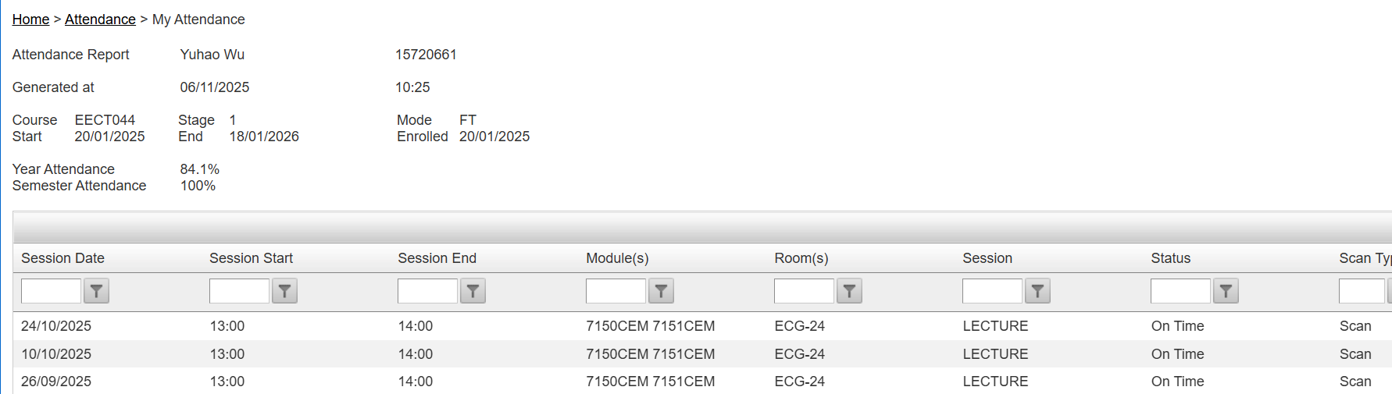
In the lecture, he mentioned that artificial intelligence is essentially a conversational machine, and that the concrete thinking process and the organisation of important content still have to be done by humans themselves. For example, he asked an AI system to write a literature review on handwritten character recognition. At first, it did not cite any survey papers. Later, even after he asked it to add references, it still failed to cite Geoffrey Hinton’s most representative paper.


All the important points that supervisor John Halloran has mentioned:

1. Meetings and administrative arrangements
There will be a fixed 20-minute one-to-one meeting at this time every week; the previous group meetings have been cancelled. The supervisor forgot to add me to the recurring meeting series, but will fix this after the meeting and send me an invitation. During the meetings I need to share my screen to present experiments and materials.

2. Grades and formal feedback
The official grade will be released the following day; my current mark is 64.
The supervisor sent me a brief written summary and the score in advance; the full rubric and detailed item-by-item feedback can be viewed on Turnitin. He hopes I will read it and then discuss it with him in the meeting.

3. Overall evaluation of the proposal and main issues
Overall it is good and promising; it looks like the project will have depth, be interesting, and can be completed to a good standard.
The main issues are in the writing: the language is too complex; the literature review is too short and jumps into specific model-level technical details too early, with a perspective that is not broad enough.

4. What the literature review should contain and how it should be written
Start from the beginning of the problem space; do not assume the reader already knows the background. Good research “educates the reader”.
Answer these key questions: why HAR is needed, why it is important/interesting, where and how it is used, how it is detected, what the current state of the art is, what open research questions remain, and how your own work connects to these gaps.
Write for a “smart outsider” (someone with higher education but not a specialist in the field), not just for the supervisor or the department. This is the default expectation in academic writing.
Aim for “accessible technical writing”: clear, well-structured, and suitable for a broad audience.
Use the literature review to learn how experts write: read more academic papers and observe their writing style and structure.
Recommended textbook: a “Machine Learning” style book that covers scikit-learn, Keras, and TensorFlow (he has already sent the Amazon link). Its writing is excellent and can be used as a style model. The beginning of the book is written for complete beginners, so I can aim slightly above that level. The later chapters’ descriptions of models match the level of difficulty of my project. The supervisor will support me and his other students in improving our writing.

5. Model selection and explanation (value-add point)
A common risk in industry and practice is that some people “only know how to run the code, but do not really know what they are doing or why they chose that model” (the supervisor stressed this was not a criticism of me personally).
A highly value-adding approach is to explain the mechanisms of the models and the reasons for choosing them in depth and with technical detail (for example, KNN, Random Forest and other baselines), and to clarify why they are used for comparison.
I should make use of what I learned in last semester’s machine learning module; when experiments use these models as baselines, I need to clearly explain “why”.

6. Process and documentation (linked to the process mark)
After each meeting, I should produce “evidence of the meeting”: what we discussed and why we discussed it; what questions the supervisor asked me and how I answered; what questions I asked and how the supervisor answered; and the action items.
The explicit action items from this meeting are:

* Clearly write up the three models (their principles, reasons for choosing them, and how they relate to the task);
* Clearly write up the experiments completed so far (settings, results, comparisons).

I should keep weekly, dated records: what I did in each week, when I did it, and why I did it at that time, and relate this to my plan.
In the dissertation I should create a separate section called “Process” and continuously write up my workflow there; the supervisor can then give more detailed suggestions based on that.
The supervisor is not worried about my process: I clearly already have one. I should continue the good habits of delivering work early, completing ethics applications early, and consistently bringing results to discuss.

